

**PROJECT**

**HOLLA CELL**

Group 4

Names : Dhayu Wiragusti

Muhammad Kara Maritza

Muhammad Valiant Althaf Alhakim

Class : 1CC5

**Continuing Education Center for Computing and Information Technology**

**Faculty of Engineering, University of Indonesia**

**Kampus Baru UI Depok 16424**

**2022**

Developed By

1. Dhayu Wiragusti
2. Muhammad Kara Maritza
3. Muhammad Valiant Althaf Alhakim



**PROJECT ON**

Batch Code :

Start Date : Sunday, December 19, 2022   
End Date :

Name of Faculty : Tirta Akdi Toma Mesoya Hulu

Names of Developer :

1. Dhayu Wiragusti
2. Muhammad Kara Maritza
3. Muhammad Valiant Althaf Alhakim

Date of Submission :



**PROJECT ON**

This is to certify that this report titled “Holla Cell” embodies the original work done by Dhayu Wiragusti, Muhammad Kara Maritza, and Muhammad Valiant Althaf Alhakim. Project in partial fulfillment of their course requirement at NIIT & CCIT-FT UI.

Coordinator:

Tirta Akdi Toma Mesoya Hulu

**CERTIFICATE**

Thank you, the author wishes to God the Almighty for His blessings and grace, we can complete this project task both in the form of presentation and paper in a timely manner.

The author also delivers him gratitude to Mr. Tirta Akdi Toma Mesoya Hulu faculty and other faculty for all guidance to complete it. Thank you to fellow students who have supported, and also thank you to fellow workers in the education at CCIT-FT UI. The Project paper entitled “Build Holla Store Database, Base on Mobile App” the author submits as a requirement for the Project assignment in 2022.

Finally, the authors hope this paper can be useful for all and also gain a better insight into the operating system. The author realizes that it is still imperfect. Therefore, the authors really expect all suggestions and criticisms from readers who are constructive in order for the perfection of this paper. Hopefully, this paper can provide many benefits for the readers.

**ACKNOWLEDGEMENT**

**System Summary :**

The database is a management process that is usually used in an organization, office, business, and others. The project is entitled Holla Cell. Holla Cell is a database of management processes at the cell phone counter, containing several components such as Employees, Employee Info, Items, Items Info, and Transactions. These tables are interconnected, for example, Employee info with Transactions and so on.

In this project, our group implemented database savings, in the form of an Entity Relationship Diagram (ERD), Database Design, Schematic Design, Table Design, Validation, and Configuration.

**SYSTEM ANALYSIS**

**Database Name :** Holla Cell

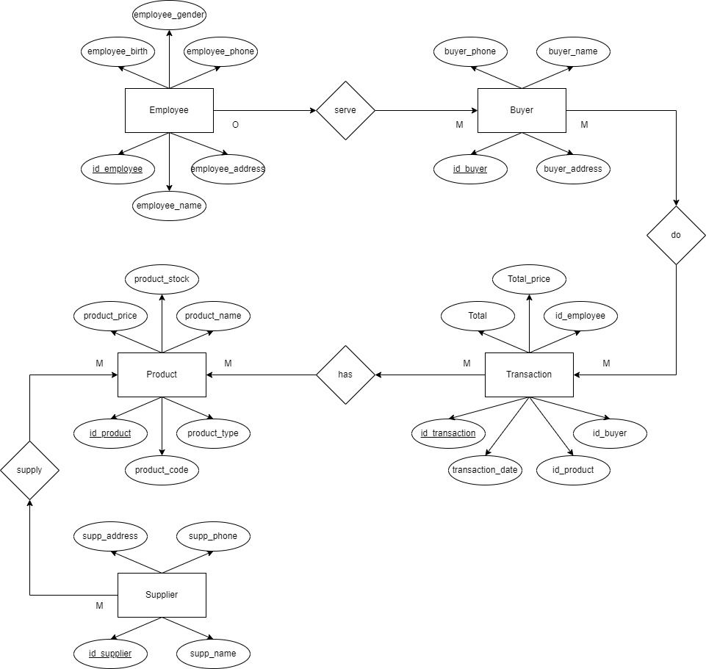

**ENTITY RELATIONSHIP DIAGRAM**

**Database Name :** Holla_Cell

**Number of Schema :** 3

1. Human
2. Object
3. Trans

**Number of Tables :** 5

1. Employee
2. Product
3. Supplier
4. Buyer
5. Transaction

**DATABASE DESIGN**

**Database Name :** Holla Cell

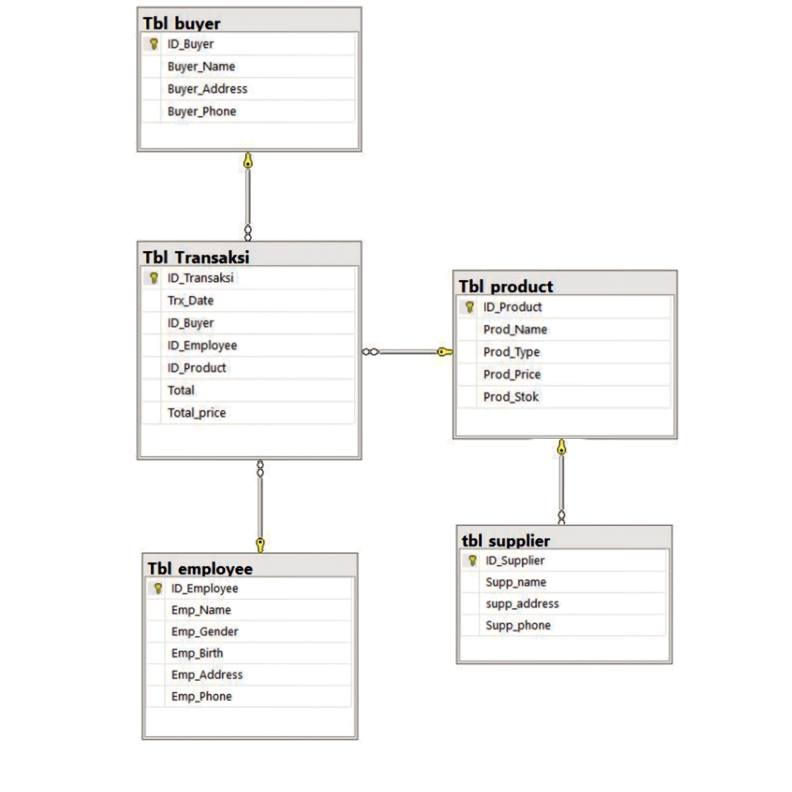

**SCHEMATIC DIAGRAM**

**Employe Table**

|  |  |  |  |
| --- | --- | --- | --- |
| Field Name | Data Type | Width | Description |
| Id_employe | Int | 5 | Identity of the Employee |
| employe_name | Varchar | 10 | Name of the Employee |
| employe_address | Varchar | 55 | Address of the Employee |
| employe_birth | Varchar | 15 | Birth of the Employee |
| employe_gender | Varchar | 1 | Gender of the Employee |
| employe_phone | Varchar | 10 | Phone number of the Employee |

**Product Table**

|  |  |  |  |
| --- | --- | --- | --- |
| Field Name | Data Type | Width | Description |
| Id_product | Int | 5 | Identity of the product |
| product_code | Varchar | 10 | Code of the product |
| product_type | Varchar | 55 | Type of the product |
| product_name | Varchar | 55 | Name of the product |
| product_price | Money |  | Price of the product |
| product_stock | Varchar | 10 | Product stok of the product |

**TABLE DESIGN**

**Buyer Table**

|  |  |  |  |
| --- | --- | --- | --- |
| Field Name | Data Type | Width | Description |
| Id_buyer | Int | 5 | Identity of the buyer |
| buyer_name | Varchar | 55 | Name of the buyer |
| buyer_address | Varchar | 55 | Address of the buyer |
| buyer_phone | Varchar | 55 | Phone number of the buyer |

**Transaction Table**

|  |  |  |  |
| --- | --- | --- | --- |
| Field Name | Data Type | Width | Description |
| Id_transaction | Int | 5 | Identity of the transaction |
| transaction_date | Date |  | Date of the transaction |
| Id_buyer | Varchar | 55 | Identity of the buyer |
| Id_employe | Varchar | 55 | Identity of the employe |
| Total | Varchar | 55 | Total of items purchased |
| total_price | Money |  | Total price of the transaction |
| Id_product | Int | 5 | Identity of the product |

**TABLE DESIGN**

**Supplier Table**

|  |  |  |  |
| --- | --- | --- | --- |
| Field Name | Data Type | Width | Description |
| Id_supplier | Int | 5 | Identity of the supplier |
| supplier_name | Varchar | 55 | Name of the supplier |
| supplier_address | Varchar | 55 | Address of the supplier |
| supplier_phone | Varchar | 55 | Phone number of the supplier |

**TABLE DESIGN**

**System Summary :** Holla_Cell

**Employee Table**

|  |  |
| --- | --- |
| **Validation Required** | **Method(s) Used for Validation** |
| EMPLOYE_ID must unique | Primary Key, Check Constraint, Not Null |
| Name, Address, Birth | Not Null |
| Gender | Check Constraint, Not Null |
| Phone | Not Null |

**Product Table**

|  |  |
| --- | --- |
| **Validation Required** | **Method(s) Used for Validation** |
| PRODUCT_ID must be unique | Primary Key, Not Null |
| Code, Type | Check Constraint, Not Null |
| Name | Not Null |
| Price, Stock | Check Constraint, Not Null |

**Buyer Table**

|  |  |
| --- | --- |
| **Validation Required** | **Method(s) Used for Validation** |
| BUYER_ID must be unique | Primary Key, Not Null |
| Name, Address, Phone | Check Constraint, Not Null |

**VALIDATION PERFORMED**

**Transaction Table**

|  |  |
| --- | --- |
| **Validation Required** | **Method(s) Used for Validation** |
| TRANSACTION_ID must be unique | Primary Key, Not Null |
| BUYER_ID, EMPLOYEE_ID, PRODUCT_ID must be unique | Foreign Key, Check Constraint, Not Null |
| Date, Total, Total_Price | Check Constraint, Not Null |

**Supplier Table**

|  |  |
| --- | --- |
| **Validation Required** | **Method(s) Used for Validation** |
| SUPPLIER_ID must be unique | Primary Key, Not Null |
| Name, Address, Phone | Check Constraint, Not Null |

**VALIDATION PERFORMED**

**Hardware :**

**Operating System :**

Microsoft Windows 10 Pro

**Software :**

Microsoft SQL Server 2019, Microsoft Office Pro 365

|  |  |  |
| --- | --- | --- |
| **PROJECT FILE DETAILS** | | |
| **No.** | **File Name** | **Remarks** |
| 1. | Holla_Cell Project.sql | File from SQL Management Studio that contain Create, Insert, Update, Constraint, Trigger, and Storage Procedure |
| 2. | Holla_Cell Project.docx | File from MS Word that contain our research project |
| 3. | Holla_Cell Presentation.ppt | File from MS Power Point for Presentation |

**CONFIGURATION**